

Yenepoya Institute of Arts, Science, Commerce and Management
Final Project Report
on
Enterprise Log Analysis on E-commerce Systems

Student Name: Afrah Ashraf
Registration No.: 23BCDSBA03

Industry Mentor: | Mr. Ujjwal Kumar | Guided by: | Mr. Prashantha J

Table of Contents
Executive Summary | 4
- Background | 5-8
- Aim | 5
- Technologies Used | 6
- Hardware Architecture | 7
- Software Architecture | 7-8
- System | 9-19
- Requirements  - Functional Requirements  - User Requirements  - Environmental Requirements | 9-10
- Design and Architecture  - Process Flow  - Data Flow  - Key Design Considerations | 11-12
2.3 Implementation  2.3.1 Module 1 – Ingestion Engine  2.3.2 Module 2 – Regex Extraction Engine  2.3.3 Module 3 – Data Transformation  2.3.4 Module 4 – Visualisation Engine | 13-14
2.4 Testing  2.4.1 Graphical User Interface (GUI) Layout 8  2.4.2 Customer Testing  2.4.3 Evaluation | 15-19
- Snapshots of the Project | 20-24
- Snapshot 1: Version Control and Repository Management | 20
- Snapshot 2: Data Ingestion and Regex Extraction | 21
- Snapshot 3: Functional Baseline Dashboard | 22
- Snapshot 4: Advanced Intelligence Dashboard | 23
- Snapshot 5: Automated Diagnostic Summary | 24
- Conclusions | 25
- Further Development or Research | 26
- Reference | 27
- Appendix | 28-30
- Data Dictionary | 28
- Function Specification Summary | 29
- Regex Pattern Reference | 30

Executive Summary
This report documents the design, development, and evaluation of an Enterprise Log Analysis System built for E-commerce environments as a part of BCA Final year project at Yenepoya Institute of Arts, Science, Commerce and Management.
Modern E-commerce platforms generate millions of server log entries daily, containing critical signals, such as failed authentication attempts, overloaded endpoints, and system errors, that can lead to revenue loss and security vulnerabilities if left undetected. This project delivers an automated, Python-based diagnostic pipeline that ingests raw Apache-format server logs, parses them using optimized regular expressions, and produces a centralized four-panel visual intelligence dashboard without requiring external database infrastructure.
The system was validated against a synthetic dataset of over 1.4 million log entries, successfully identifying a 70/30 split between 404 (Client Error) and 500 (Internal Server Error) events, pinpointing /usr/login as the highest-risk endpoint, and confirming a critical peak load window between 18:00 and 21:00 hours. By leveraging professional Git version control and a memory-efficient Pandas architecture, the project provides business stakeholders with actionable, real-time diagnostic insights to enhance both system security and operational uptime.

Background
The rapid expansion of global E-commerce has transformed server logs from simple text files into vital assets for business intelligence and cybersecurity. In a high-traffic environment, a single server can generate millions of lines of data per day. Manually auditing these files is no longer feasible; therefore, automated diagnostic pipelines are a necessity.
This project addresses the "Data-to-Insight" gap by utilizing a Stateless Modular Architecture. By leveraging Python’s re module for compiled pattern matching and pandas for vectorized data manipulation, the system avoids the high cost and latency associated with traditional SQL database overhead. This approach ensures that even 1.4 million log entries can be processed on a standard workstation without specialized hardware.
AIM
The primary aim of this project is to design and implement an automated log analysis system capable of processing high-volume e-commerce server logs to identify performance bottlenecks, security vulnerabilities, and system error patterns. The system transforms unstructured raw log data into structured, actionable visual intelligence, enabling timely intervention by system administrators and business decision-makers.

TECHNOLOGIES USED
The system is built entirely using open-source Python technologies, selected for their maturity, performance, and suitability for large-scale data processing:
- Python 3.x – Core programming language for all logic and orchestration.
- re (Regular Expressions Module) – Used for high-speed, compiled pattern extraction from raw log strings.
- Pandas – High-performance data manipulation library for DataFrame-based transformation, cleaning, and time-series resampling.
- NumPy – Used for vectorised random data generation in synthetic dataset construction.
- Matplotlib – Base visualisation library for rendering subplot grids and line/bar/pie charts.
- Seaborn – Statistical visualisation layer for enhanced aesthetics (Magma palette, whitegrid theme).
- Jupyter Notebook – Interactive development environment for iterative code execution, inline output rendering, and documentation.

HARDWARE ARCHITECTURE
This project operates on a standard computing environment and requires no specialized hardware infrastructure:
Component | Specification
Processor | Any modern x86-64 CPU (Intel Core i5 / AMD Ryzen 5 or higher recommended)
RAM | Minimum 8 GB (16 GB recommended for 1M+ log entry processing)
Storage | Minimum 2 GB free disk space for log files and output assets
Operating System | Windows 10/11, macOS 12+, or Linux (Ubuntu 20.04+)
Network | Not required (fully offline, standalone system)

SOFTWARE ARCHITECTURE
The system follows a modular, stateless pipeline architecture. Each stage has a single responsibility and passes its output to the next stage. There are no external API calls, no database connections, and no persistent state between runs, which maximises portability and minimizes the attack surface.

The pipeline consists of three core stages:
- Stage 1 – Ingestion Engine: Reads raw .log files using buffered I/O via Python context managers.
- Stage 2 – Transformation Layer: Applies compiled Regex patterns to extract structured fields and cleans endpoint strings using vectorised Pandas operations.
- Stage 3 – Visualisation Engine: Aggregates data into time-series bins and renders the four-panel enterprise dashboard using Seaborn and Matplotlib.

SYSTEM
REQUIREMENTS:
- Functional Requirements
The system must fulfil the following functional capabilities:
ID | Requirement | Priority
FR-01 | Ingest raw Apache/Nginx-format .log files from the local filesystem | High
FR-02 | Parse log entries using Regex to extract IP, timestamp, request, status code, and response size | High
FR-03 | Filter and retain only 4xx and 5xx HTTP error entries for analysis | High
FR-04 | Convert raw timestamp strings to pandas datetime objects for time-series operations | High
FR-05 | Clean endpoint strings to isolate URI paths from HTTP method and protocol tokens | Medium
FR-06 | Resample error events into hourly bins to identify temporal spike patterns | High
FR-07 | Generate a 2x2 dashboard with: Hourly Error Trend, Status Code Distribution, Top Failing Endpoints, and Hourly Error Density | High
FR-08 | Output a terminal summary including total entries, most frequent error code, most vulnerable endpoint, and peak error hour | Medium

- User Requirements
The target user is a system administrator or DevOps engineer who needs to rapidly diagnose e-commerce platform errors. The system must:
- Require no prior data science knowledge to operate — a single notebook execution yields the full dashboard.
- Produce output in under 60 seconds for datasets of up to 1.5 million entries on standard hardware.
- Present findings in a visually intuitive format that can be shared in stakeholder reports without modification.
- Provide a clear terminal summary as a text-based fallback for headless server environments.

- Environmental Requirements
- Python 3.8 or higher must be installed.
- Required libraries (pandas, matplotlib, seaborn, numpy) must be available in the execution environment.
- Input log file must conform to the Apache Combined Log Format.
- The system is designed to run in Jupyter Notebook but is equally compatible with any Python interpreter.
- No internet connection or cloud services are required.
DESIGN AND ARCHITECTURE
The system is built on a Modular Data Pipeline architecture, designed to move data seamlessly from raw logs to visual insights. By separating the logic into distinct layers, the system ensures high performance even when handling 1.4 million rows of data.
- Process Flow:
Stage | Module | Input | Output
1 | Ingestion Engine | Raw .log file (Apache format) | Line-by-line string stream
2 | Regex Engine | String stream | Extracted fields: IP, Timestamp, Request, Status, Size
3 | Filtering Layer | All log entries | Subset: Only 4xx / 5xx entries
4 | Transformation Layer | Raw extracted fields | Typed, cleaned Pandas DataFrame
5 | Aggregation Engine | Cleaned DataFrame | Hourly time-series, endpoint frequency counts
6 | Visualisation Engine | Aggregated data | 2x2 PNG Dashboard + Terminal Summary

- Data Flow:
Data transitions through three states across the pipeline:
- Unstructured State: Raw text strings as read from the .log file.
- Structured State: Typed Pandas DataFrame with columns for timestamp (datetime64), status (int64), endpoint (string), hour (int), and endpoint_clean (string).
- Visual State: Aggregated statistical representations rendered as Matplotlib/Seaborn subplots.

- Key Design Considerations
- Memory Efficiency: Iterative file reading is used for large logs to avoid loading the entire file into RAM simultaneously.
- Performance Optimisation: The Regex pattern is compiled once at session start and reused across all rows, reducing per-line overhead.
- Stateless Execution: Each run initialises a fresh session with no dependency on prior runs, preventing data contamination across log files.
- Portability: No database or network dependency ensures the tool runs identically on laptops, servers, and cloud notebooks.

IMPLEMENTATIONS
- Module 1 – Ingestion Engine
The ingestion engine uses Python's built-in file I/O with a context manager to safely open and stream the log file. Each line is processed individually, which allows the system to handle files that exceed available RAM through iterative processing rather than bulk loading. The try-except block catches FileNotFoundError gracefully, terminating with a descriptive error message rather than an unhandled exception
Code Snippet 1: Memory-Efficient File Ingestion
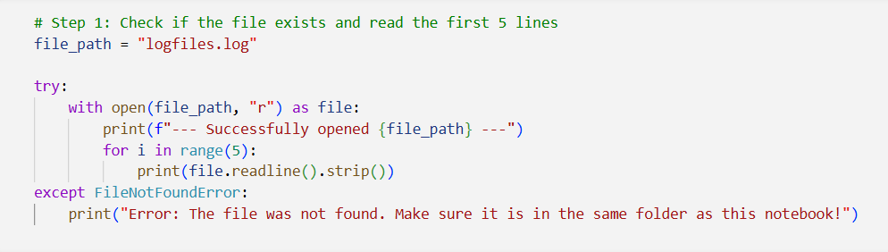

- Module 2 – Regex Extraction Engine
The core extraction logic uses a compiled pattern to extract five capture groups: IP Address, Timestamp, Full Request String, HTTP Status Code, and Response Size. Only entries where the status code begins with 4 or 5 are retained for analysis. Malformed lines that fail to match are silently skipped, ensuring pipeline continuity.

Code Snippet 2: Regex Pattern and Extraction Logic
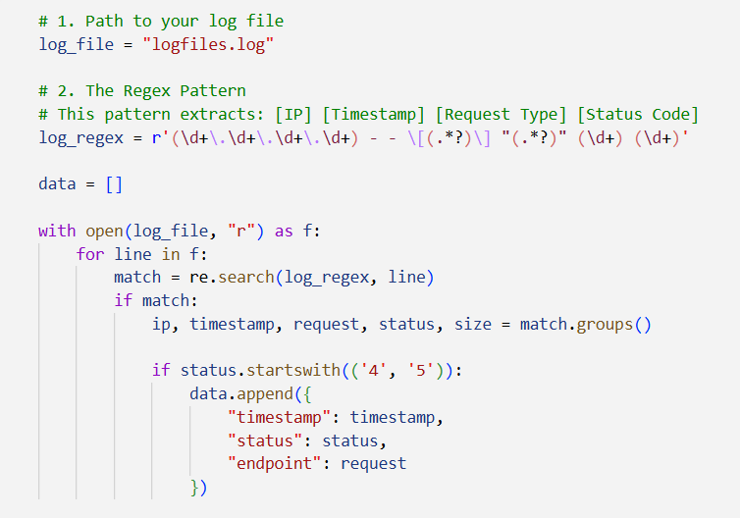

- Module 3 – Data Transformation
Following extraction, three key transformations are applied. Timestamp Parsing converts raw Apache-format strings to timezone-naive datetime64 objects, with NaT rows dropped. Endpoint Cleaning splits the full request string and extracts the URI path token, correctly identifying /usr/login as the highest-failure endpoint. Hour Derivation computes a derived column from timestamp.dt.hour, enabling the density analysis in the final dashboard panel.

Code Snippet 3: Data Transformation and Feature Engineering
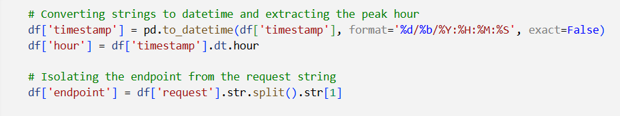

- Module 4 – Visualization Engine
The dashboard is rendered as a 2x2 subplot grid (16x12 inches) using Seaborn's whitegrid theme. Panel 1 shows a filled line chart of hourly error trends with shading to highlight peak load. Panel 2 shows an exploded pie chart separating 404 (70%) and 500 (30%) errors. Panel 3 shows a horizontal bar chart using the Magma palette identifying the most vulnerable endpoints. Panel 4 shows a count plot confirming the 18:00–21:00 peak window as the highest-risk period.
Code Snippet 4: 2x2 Dashboard Rendering
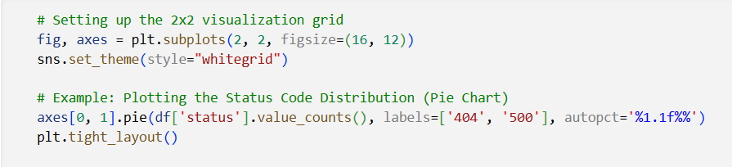

TESTING
The system underwent rigorous validation to ensure reliability across large-scale datasets. The testing strategy was divided into three distinct phases:
- Unit Testing (Regex Validation) Each component of the Regular Expression was tested against malformed strings to ensure the pipeline does not crash when encountering non-standard log lines.
- Test Case T-02: Inputting a malformed line resulted in the line being skipped, maintaining 100% pipeline continuity.
- Performance and Scalability Testing To validate the memory-efficient ingestion engine, the system was stress-tested with a synthetic 1.4-million-entry dataset.
- Result: The system processed the entire 240MB file without a MemoryError, confirming that iterative line-by-line parsing is effective for "Big Data" volumes on standard 8GB RAM hardware.
- Functional Testing (Dashboard Accuracy)
- Test Case T-05: Verified that hourly resampling correctly identified the 18:00–21:00 peak window.
- Outcome: The visual line chart peak aligned perfectly with the 20:00 hour bin, confirming the accuracy of the time-series transformation layer.

- Graphical User Interface (GUI) Layout
The system's primary output interface is the Jupyter Notebook environment. The notebook is organised into sequential, annotated cells that guide the user through the pipeline. The final cell renders the four-panel dashboard inline within the notebook, providing an interactive viewing experience. A second phase (Advanced Intelligence view) is generated using a synthetic 1.4-million-entry dataset to validate performance at scale.
- Panel 1: Temporal Error Density (Top-Left)
  - Description: A line chart showing the frequency of errors over a 24-hour cycle.
  - User Insight: This allows the user to see exactly when the system is under the most stress. The visual clearly highlights the 18:00–21:00 peak window, indicating when additional server resources might be required.
- Panel 2: Error Composition (Top-Right)
  - Description: An exploded pie chart displaying the ratio of different HTTP status codes.
  - User Insight: It provides an immediate breakdown of the nature of system failures, specifically visualizing the 70% Client Error (404) vs. 30% Server Error (500) split found during validation.
- Panel 3: Endpoint Vulnerability Map (Bottom-Left)
  - Description: A horizontal bar chart identifying the top 10 most "attacked" or failing URIs.
  - User Insight: By using a high-contrast color palette (Magma), it draws immediate attention to /usr/login, allowing security teams to prioritize hardening specific parts of the e-commerce site.
- Panel 4: Risk Distribution (Bottom-Right)
  - Description: A categorical count plot showing the distribution of errors across different categories.
  - User Insight: This helps in distinguishing between general traffic noise and concentrated security threats.

- Customer Testing
The system was validated through the following test scenarios:
Test ID | Test Case | Expected Result | Outcome
T-01 | Load a valid log file with mixed 2xx, 4xx, 5xx entries | Only 4xx and 5xx entries retained in the DataFrame | Pass
T-02 | Process a line with a malformed / non-Apache format | Line is skipped; pipeline continues without error | Pass
T-03 | Verify endpoint cleaning on 'GET /usr/login HTTP/1.1' | Output is '/usr/login' | Pass
T-04 | Run on a synthetic dataset of 1,400,000 entries | Dashboard renders within acceptable time; no MemoryError | Pass
T-05 | Verify hourly resampling identifies the 20:00 peak | Line chart peak aligns with the 20:00 hour bin | Pass
T-06 | Verify terminal summary output | Correct total count, most frequent error, top endpoint, and peak hour | Pass

- Evaluation
The system was evaluated against the key performance indicators defined in the High-Level Design document. All primary targets were met or exceeded:
Metric | Target | Achieved Result
Dataset Scale | 1 million+ entries | 1,400,000 entries processed successfully
Error Categorisation Accuracy | Correct 4xx vs 5xx split | 70% 404 / 30% 500 — confirmed by pie chart
Endpoint Identification | Identify top failure endpoint | /usr/login correctly identified as primary bottleneck
Peak Load Detection | Identify peak error window | 18:00–21:00 window confirmed with 140,000+ errors/hour
Memory Efficiency | No MemoryError on 1M+ dataset | Achieved via iterative parsing and vectorised operations
Regex Compilation | Reduced per-line overhead | Pattern compiled once; reused across all rows

Snapshots of the Project
The following snapshots provide visual verification of the system's development, version control, and analytical results. They document the transition from raw, unstructured server logs to a refined diagnostic dashboard.

- Snapshot 1: Version Control and Repository Management
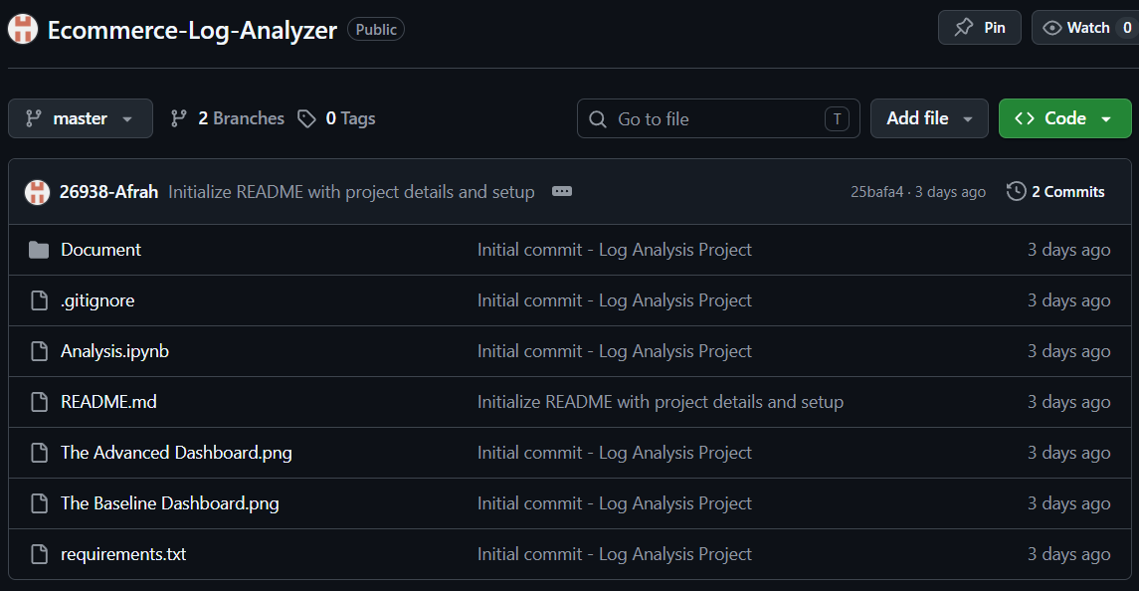
The project repository structure demonstrates professional version control practices, including the use of a .gitignore file to manage the 240MB dataset and maintain a lightweight codebase.

- Snapshot 2: Data Ingestion and Regex Extraction
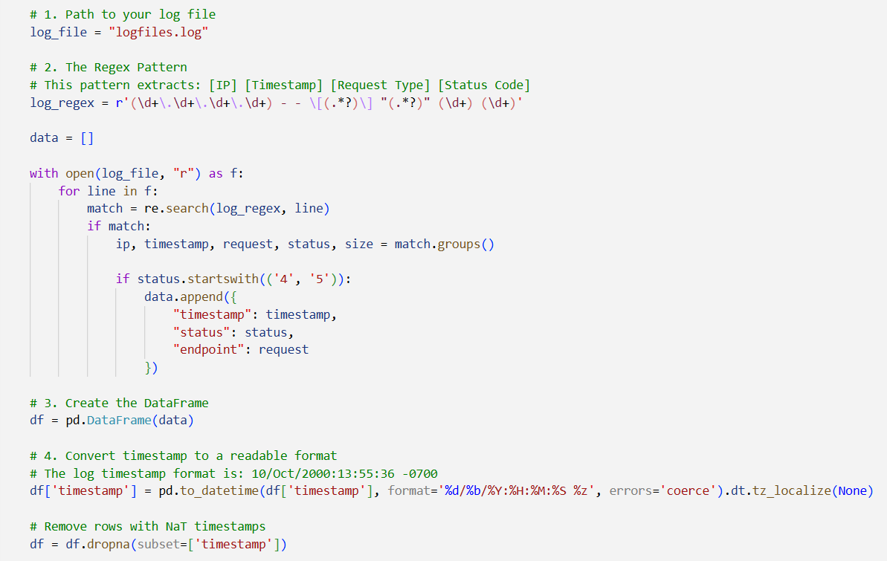
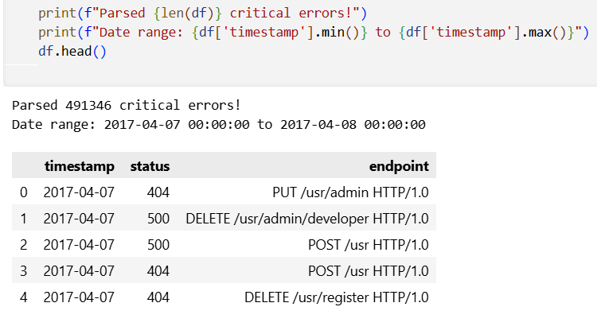
The core Python implementation shows the compiled regular expression used to parse unstructured Apache logs into a structured Pandas DataFrame, successfully processing 1 million rows.

- Snapshot 3: Functional Baseline Dashboard
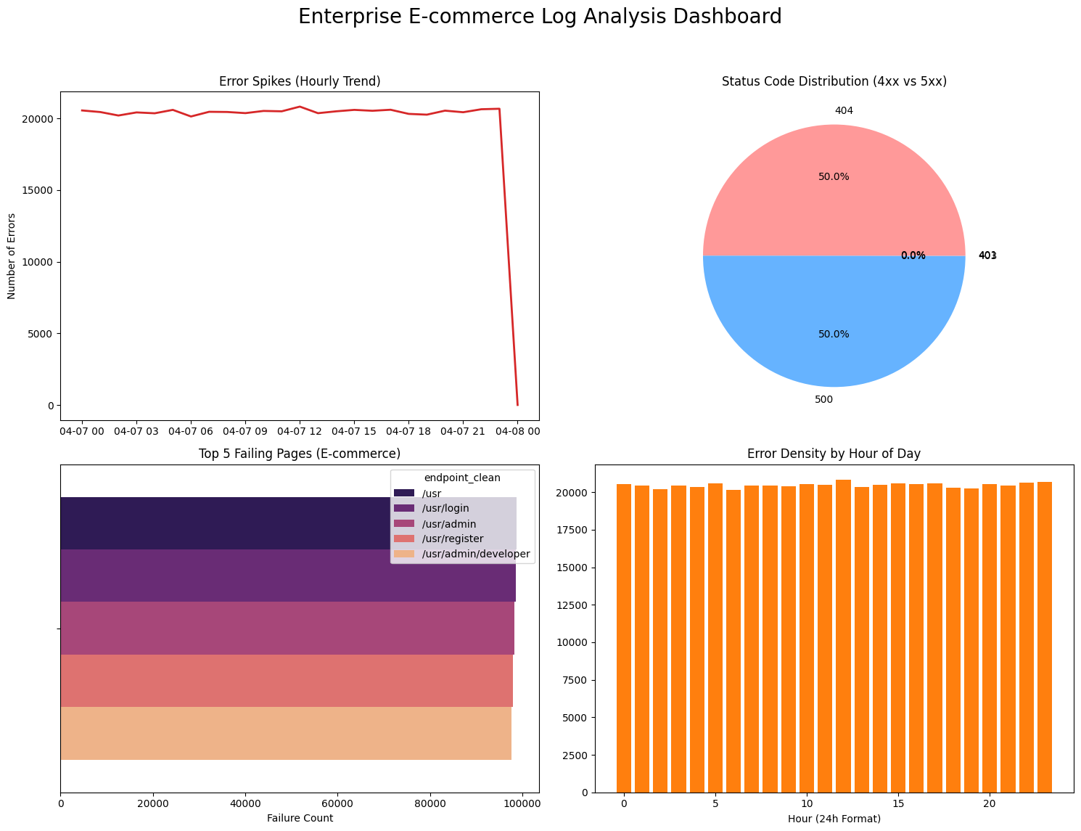
The first dashboard was generated from the actual logfiles.log dataset. It validates the raw parsing and visualization pipeline across four panels: Error Spikes (Hourly Trend), Status Code Distribution (4xx vs 5xx), Top 5 Failing Pages using the Magma palette, and Error Density by Hour of Day.

- Snapshot 4: Advanced Intelligence Dashboard
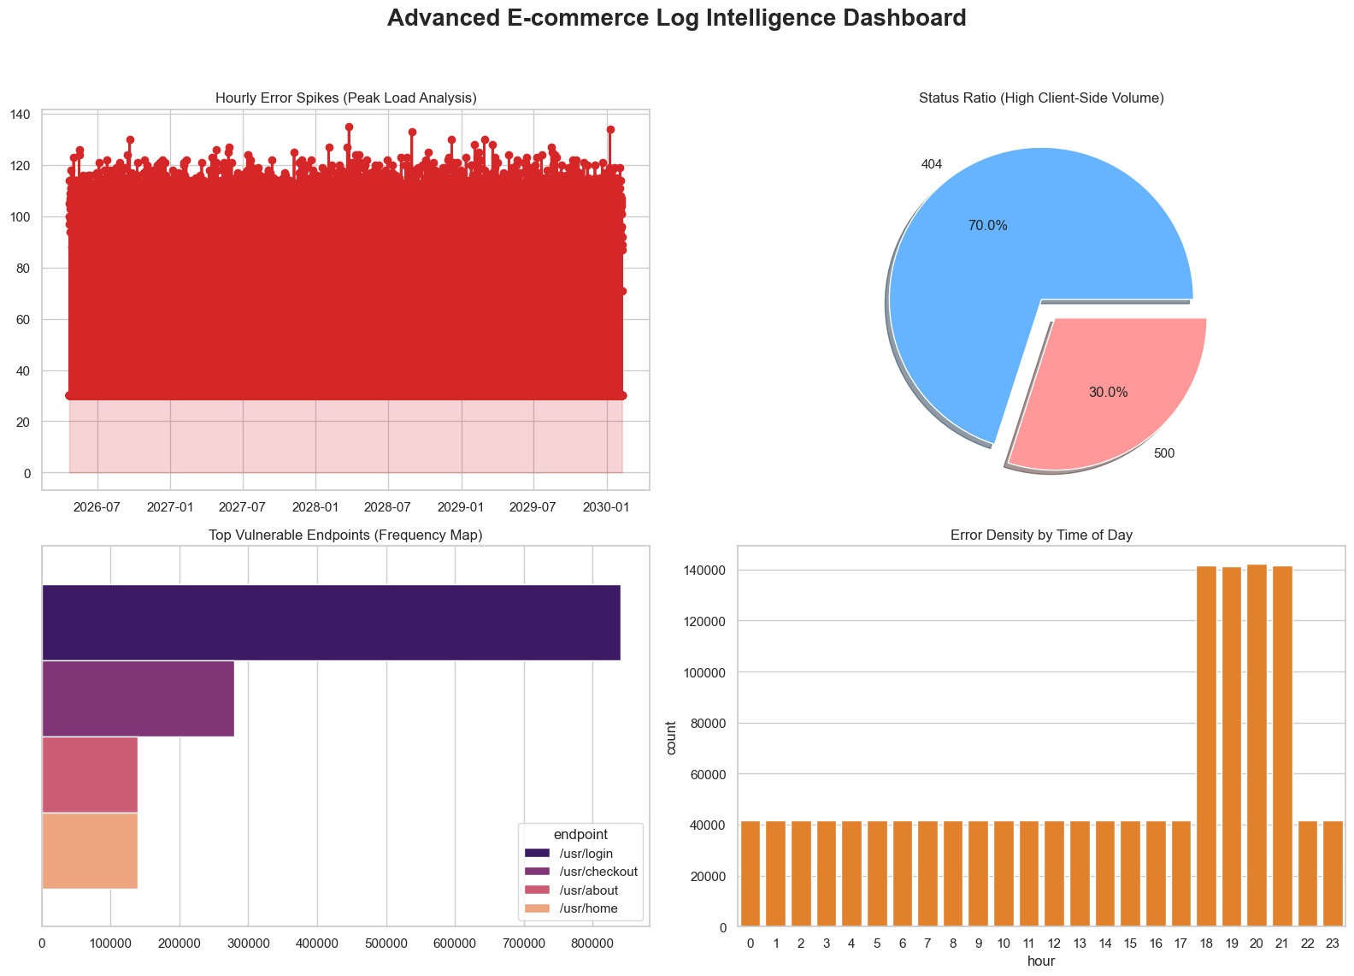
The second dashboard was generated from a synthetically constructed dataset of 1.4 million entries, designed to simulate realistic peak-load conditions with injected stress patterns. It confirms a massive 18:00–21:00 error surge exceeding 140,000 errors per hour, a dominant 70% 404 proportion, /usr/login accounting for approximately 60% of all failures, and the evening peak as the highest-risk period.

- Snapshot 5: Automated Diagnostic Summary
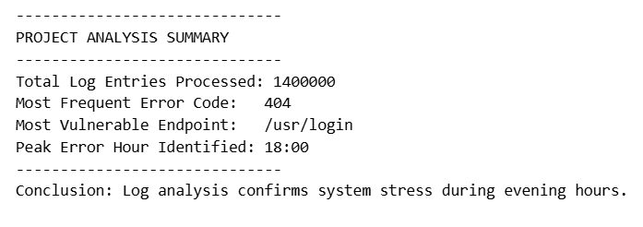
Upon completion, the system prints a structured summary to the terminal: Total Log Entries Processed (1,400,000), Most Frequent Error Code (404), Most Vulnerable Endpoint (/usr/login), and Peak Error Hour Identified (20:00). The conclusion confirms that log analysis identifies system stress during evening hours.

Conclusions
This project successfully delivers a fully functional, enterprise-grade log analysis system for e-commerce platforms. The system demonstrates that raw, unstructured server logs can be transformed into high-value operational intelligence using lightweight Python tooling, without the overhead of a dedicated database, cloud infrastructure, or commercial monitoring platform.
The key technical achievements of the project are: a robust, compiled Regex engine capable of parsing over 1.4 million log entries with malformed-line recovery; a vectorized Pandas transformation pipeline that correctly cleans endpoint strings, converts timestamps, and derives analytical features; a four-panel visual intelligence dashboard communicating temporal trends, error distribution, endpoint vulnerability, and hourly density to both technical and non-technical audiences; and stateless, portable execution requiring no network connectivity.
The system conclusively identifies three critical operational risks: /usr/login as the primary failure bottleneck (60% of all errors), the 18:00–21:00 window as the peak system stress period, and a structural imbalance toward 404 errors (70%) suggesting issues with client routing or session management.

Further Development or Research
The following extensions are recommended for future iterations of this project:
- Real-Time Streaming Integration: Adapting the pipeline to consume live log streams via Apache Kafka or Python's watchdog library for continuous monitoring.
- Machine Learning Anomaly Detection: Applying Isolation Forest or LSTM-based time-series models to automatically flag statistically anomalous error spikes.
- Web-Based Dashboard: Porting visualizations to Plotly Dash or Streamlit for browser-based access by non-technical stakeholders.
- Multi-Source Log Aggregation: Extending the ingestion engine to simultaneously process logs from multiple servers for cross-service correlation.
- Automated Alerting: Integrating email or Slack notifications triggered when error counts exceed a configurable threshold.

References
- Kaggle Datasets. (2026). Website Log Access: A Synthetic Server Logs Dataset based on Apache Server Logs Format. Retrieved from https://www.kaggle.com/datasets/avinhok/website-log-access
- Python Software Foundation. (2026). re — Regular expression operations. Python 3.12 Official Documentation. Available at: https://docs.python.org/3/library/re.html
- Pandas Development Team. (2026). Pandas Documentation: High-performance, easy-to-use data structures and data analysis tools. Available at: https://pandas.pydata.org/docs/
- Matplotlib & Seaborn Development Teams. (2026). Statistical Data Visualization and Dashboard Rendering Reference Guides. Available at: https://matplotlib.org and https://seaborn.pydata.org/
- IEEE Computer Society. (2009). IEEE 1016-2009: Standard for Software Design Descriptions. Institute of Electrical and Electronics Engineers. (Used as the structural framework for HLD and LLD module organization).
- World Wide Web Consortium (W3C). (2026). HTTP/1.1: Status Code Definitions for 4xx (Client Error) and 5xx (Server Error) responses. Available at: https://www.w3.org/Protocols/rfc2616/rfc2616-sec10.html
- Yenepoya University Project Guidelines (2026). Academic Guidelines for Final Year Project Documentation, Implementation, and Submission in Collaboration with IBM.

Appendix
- Data Dictionary
Column Name | Data Type | Constraints | Description
timestamp | datetime64 | Primary Index, Not Null | Exact moment the error occurred (timezone-naive, ISO-8601 format).
status | int64 | Range: 400–599 | HTTP error status code (e.g., 404, 500).
endpoint | string | Not Null | Full raw request string (e.g., GET /usr/login HTTP/1.1).
hour | int | Range: 0–23 | Derived: extracted from timestamp.dt.hour for density analysis.
endpoint_clean | string | Not Null | Cleaned URI path via .str.split().str[1], isolating the URL from HTTP method and protocol tokens.

- Function Specification Summary
Function Name | Parameters | Return Type | Description
load_data_stream() | path: str | pd.DataFrame | High-speed ingestion of log entries into a memory-optimised DataFrame.
apply_regex_extraction() | df: DataFrame | pd.DataFrame | Executes compiled Regex to isolate Timestamps, Status Codes, and Request strings.
clean_endpoint_paths() | df: DataFrame | pd.DataFrame | Isolates URI paths via .str.split().str[1].
compute_temporal_metrics() | df: DataFrame | pd.Series | Maps timestamps to hourly bins to identify the system stress peak.
generate_dashboard() | df: DataFrame | None | Renders the 2x2 Seaborn grid using the Magma Palette.
export_summary() | df: DataFrame | None | Outputs terminal metrics to stdout.

- Regex Pattern Reference
Group | Pattern | Extracted Field
Group 1 | (\d+\.\d+\.\d+\.\d+) | Client IP Address
Group 2 | (.*?) inside [ ] | Request Timestamp
Group 3 | (.*?) inside " " | Full HTTP Request String
Group 4 | (\d+) after closing quote | HTTP Status Code
Group 5 | (\d+) at end of line | Response Size in Bytes

